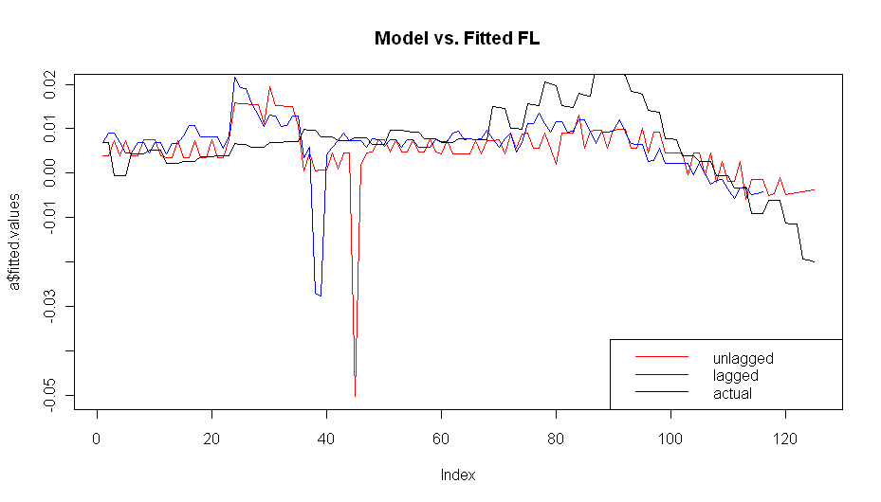
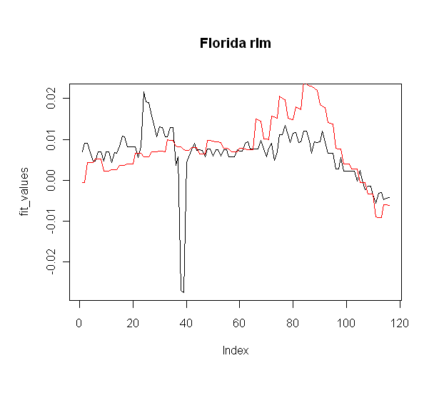
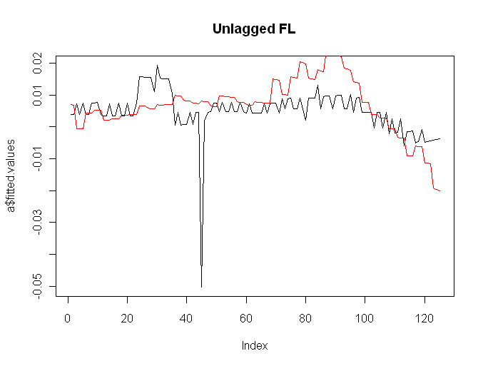

Final model:
median_income | thirty_year_commitment_rate | mortgage_originations | unemployment_rate | population_size | foreclosures | building_permits
0 | 0 | 0 | -4#-3 | -6#3 | 0 | 0

> summary(y)

Call: rlm(x = shifted.multivar.test.data.vector[, 1:(n - 1)], y = shifted.multivar.test.data.vector[,
n])
Residuals:
Min 1Q Median 3Q Max
-0.0158725 -0.0025188 0.0005815 0.0047415 0.0351508

Coefficients:
Value Std. Error t value
unemployment_rate-Lag-4 -0.0960 0.0155 -6.1967
unemployment_rate-Lag-3 -0.0931 0.0155 -6.0056
population_size-Lag-6 1.0066 0.4107 2.4510
population_size-Lag3 2.7738 0.4080 6.7994

Residual standard error: 0.004983 on 112 degrees of freedom

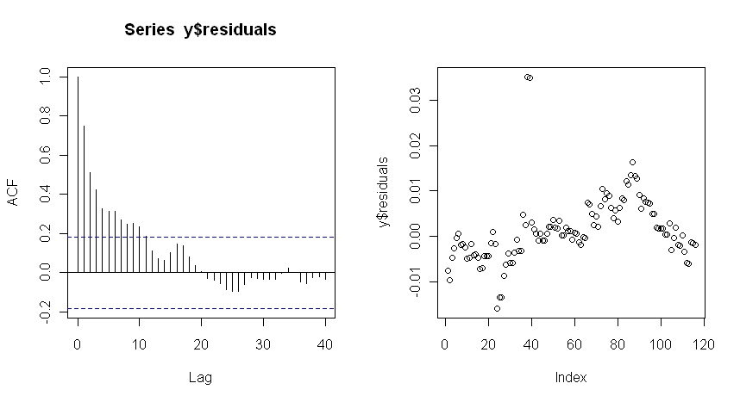

Box-Ljung test

data: y$residuals
X-squared = 196.3789, df = 12, p-value < 2.2e-16

Augmented Dickey-Fuller Test

data: y$residuals
Dickey-Fuller = -2.5303, Lag order = 4, p-value = 0.3565
alternative hypothesis: stationary

